Product Details:
ARC Solar Glass with High Transmittance, combined with nanometer anti-reflective coating technology, increases solar transmittance by way of decreasing light reflectance, Thus increasing the solar cell efficiency. Meanwhile, it reduces the reflected glare of the glass and the pollution caused by the reflectance to the environment. The hydrophobic behavior of the AR coating could in some degree protect the dust and dirt from shading the light and improve the self-cleaning of the glass.
ARC Solar Glass With High Transmittance
Thickness range | 1.6-4.0mm
Maximum Size | 1400*2400mm
Minimum Size | 300*300mm
Solar Transmittance  (Wavelength Range 380-1100nm) | ≥93.8%
Performance | Hardness ≥ 4H；  Light transmittance gain：2.3%~2.5%；  Adhesion：0 level
Quality Standard | Meets the standards of JC/T2170-2013；AS/NZS2208:1996；  EN12150/DIN1249D；ASTM-E-903（891）-96；JIS and etc.
Packaging | Keep wood pallets Flat or keep open create upright;  packaging also can be customized
Advantages | 1.Combined with nanometer anti-reflective coating technology, glass surface forms a dense structure of high -gain film, which increase 2.3%-2.5% of solar transmittance;  2. Good performance on acid and alkali resistance under terrible environments outdoor.
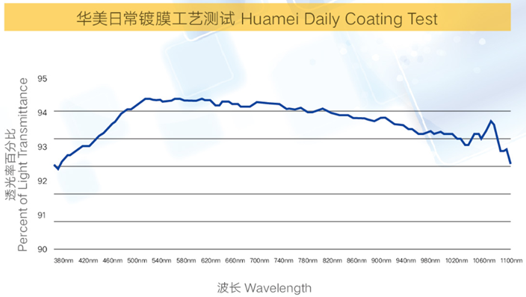
Daily Coating Test

