Technical data and design
Dimensions | 166mm*166mm± 0.3mm | TkVoltage：-0.36 %/K
Thickness | 170±30μm | TkCurrent：+0.07%/K
Front(-) | 9*0.1±0.05mm busbar (silver)，146 fingers  Anti-broken grid design, blue anti-reflection film (silicon nitride) | TkPower：-0.38%/K
Back(+) | Back electrode width (silver) 1.4 ±0.5mm, back surface covered by fingers  150 fingers on the back, anti-broken grid design | Rsh≥35Ω，Irev2≤0.8A
Light intensity reliability
Intensity(W/m²) | 1000 | 900 | 800 | 600 | 400
Uoc | 1.000 | 0.996 | 0.991 | 0.988 | 0.962
Isc | 1.000 | 0.903 | 0.803 | 0.602 | 0.403
* Taking the Voc(Isc) tested at 1000W/m2 as the standard, test the decrease of Voc (Isc) with the light intensity.
Solderability
Minimum peeling strength | ≥1.4N/mm
Results may vary depending on electrode, welding method, and conditions.

IV curve
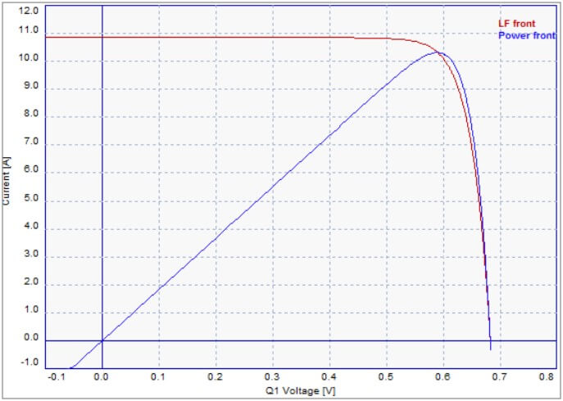

Front electrical performance distribution
Efficiency code | Efficiency  Eff(%) | Maximum output power  Pmpp(W) | Maximum output voltage  Umpp(V) | Maximum output current  Impp(A) | Open-circuit voltage  Uoc(V) | Short-circuit current  Isc(A) | Fill factor  FF(%)
166M-233 | 23.3 | 6.39 | 0.5927 | 10.799 | 0.6929 | 11.284 | 81.71
166M-232 | 23.2 | 6.36 | 0.5915 | 10.752 | 0.6917 | 11.261 | 81.65
166M-231 | 23.1 | 6.33 | 0.5901 | 10.727 | 0.6905 | 11.246 | 81.51
166M-230 | 23.0 | 6.31 | 0.5886 | 10.714 | 0.6893 | 11.230 | 81.48
166M-229 | 22.9 | 6.28 | 0.5871 | 10.690 | 0.6881 | 11.216 | 81.36
166M-228 | 22.8 | 6.25 | 0.5856 | 10.674 | 0.6869 | 11.201 | 81.24
166M-227 | 22.7 | 6.22 | 0.5843 | 10.650 | 0.6856 | 11.187 | 81.14
166M-226 | 22.6 | 6.20 | 0.5826 | 10.635 | 0.6847 | 11.172 | 81.00
166M-225 | 22.5 | 6.17 | 0.5811 | 10.615 | 0.6835 | 11.158 | 80.88
166M-224 | 22.4 | 6.14 | 0.5795 | 10.598 | 0.6823 | 11.142 | 80.78
166M-223 | 22.3 | 6.11 | 0.5779 | 10.579 | 0.6811 | 11.128 | 80.66
166M-222 | 22.2 | 6.09 | 0.5764 | 10.559 | 0.6793 | 11.121 | 80.57
166M-221 | 22.1 | 6.06 | 0.5749 | 10.540 | 0.6789 | 11.103 | 80.38
166M-220 | 22 | 6.03 | 0.5731 | 10.525 | 0.6776 | 11.090 | 80.26
166M-219 | 21.9 | 6.00 | 0.5716 | 10.503 | 0.6765 | 11.073 | 80.15
166M-218 | 21.8 | 5.98 | 0.5700 | 10.485 | 0.6753 | 11.057 | 80.04
166M-217 | 21.7 | 5.95 | 0.5684 | 10.467 | 0.6742 | 11.042 | 79.91
166M-216 | 21.6 | 5.92 | 0.5669 | 10.446 | 0.6729 | 11.028 | 79.80
166M-215 | 21.5 | 5.89 | 0.5654 | 10.426 | 0.6717 | 11.011 | 79.70
Standard test conditions:1000W/m², AM1.5, 25℃
The above technical parameters are subject to technical changes and tests.
Back electrical performance distribution
Efficiency code | Efficiency  Eff(%) | Maximum output power  Pmpp(W) | Maximum output voltage  Umpp(V) | Maximum output current  Impp(A) | Open-circuit voltage  Uoc(V) | Short-circuit current  Isc(A)
166M-16.2 | >16% | 4.44 | 0.5884 | 7.549 | 0.6788 | 8.019
166M-15.7 | 15.5%-16% | 4.30 | 0.5782 | 7.492 | 0.6688 | 7.940
166M-15.2 | >15%-15.5% | 4.17 | 0.5721 | 7.335 | 0.6650 | 7.735
166M-14.8 | <15% | 4.06 | 0.5657 | 7.173 | 0.6592 | 7.554
Standard test conditions:1000W/m², AM1.5, 25℃
The above technical parameters are subject to technical changes and tests.

