Technical data and design
Dimensions | 210mm*210mm±0.25mm | TkVoltage：-0.36 %/K
Thickness | 180±20μm | TkCurrent：+0.07%/K
Front (-) | 12*0.06±0.04mmbusbar (silver), 174±15 fingers  Blue (dark blue) color antireflective film (silicon nitride composite film) | TkPower：-0.38%/K
Back (+) | Back electrode width (silver) 2.12 ±0.4mm, back covered with fingers | Rsh≥50Ω，Irev2≤0.5A
Light intensity reliability
Intensity(W/m²) | 1000 | 900 | 800 | 600 | 400
Uoc | 1.000 | 0.996 | 0.991 | 0.988 | 0.962
Isc | 1.000 | 0.903 | 0.803 | 0.602 | 0.403
* Taking the Voc(Isc) tested at 1000W/m2 as the standard, test the decrease of Voc (Isc) with the light intensity.
Solderability
Minimum peeling strength | ≥1.1N/mm
Results may vary depending on electrode, welding method, and conditions.

IV curve
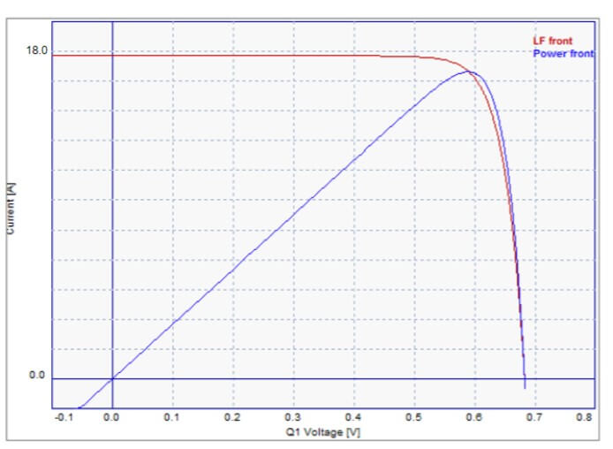
Front electrical performance distribution
Efficiency code | Efficiency  Eff(%) | Maximum output power  Pmpp(W) | Maximum output voltage  Umpp(V) | Maximum output current  Impp(A) | Open-circuit voltage  Uoc(V) | Short-circuit current  Isc(A) | Fill factor  FF(%)
210M-231 | 23.1 | 10.18 | 0.590 | 17.261 | 0.690 | 18.186 | 81.15
210M-230 | 23.0 | 10.14 | 0.589 | 17.216 | 0.689 | 18.166 | 81.01
210M-229 | 22.9 | 10.10 | 0.587 | 17.206 | 0.688 | 18.140 | 80.93
210M-228 | 22.8 | 10.05 | 0.586 | 17.151 | 0.687 | 18.125 | 80.71
210M-227 | 22.7 | 10.01 | 0.584 | 17.140 | 0.686 | 18.108 | 80.58
210M-226 | 22.6 | 9.97 | 0.583 | 17.101 | 0.685 | 18.088 | 80.46
210M-225 | 22.5 | 9.92 | 0.581 | 17.074 | 0.685 | 18.062 | 80.18
210M-224 | 22.4 | 9.88 | 0.579 | 17.064 | 0.684 | 18.049 | 80.02
210M-223 | 22.3 | 9.83 | 0.577 | 17.036 | 0.682 | 18.030 | 79.94
210M-222 | 22.2 | 9.79 | 0.575 | 17.026 | 0.681 | 18.016 | 79.79
210M-221 | 22.1 | 9.75 | 0.574 | 16.986 | 0.680 | 17.995 | 79.68
Standard test conditions:1000W/m², AM1.5, 25℃
The above technical parameters are subject to technical changes and tests.
Back electrical performance distribution
Efficiency code | Efficiency  Eff(%) | Maximum output power  Pmpp(W) | Maximum output voltage  Umpp(V) | Maximum output current  Impp(A) | Open-circuit voltage  Uoc(V) | Short-circuit current  Isc(A)
210M-16.0 | >16 | 7.06 | 0.582 | 12.130 | 0.677 | 13.361
210M-15.7 | 15.5-16 | 6.92 | 0.579 | 11.952 | 0.675 | 13.352
210M-15.2 | >15-15.5 | 6.70 | 0.572 | 11.713 | 0.673 | 13.244
210M-14.8 | <15 | 6.53 | 0.565 | 11.558 | 0.672 | 13.124
Standard test conditions:1000W/m², AM1.5, 25℃
The above technical parameters are subject to technical changes and tests.

