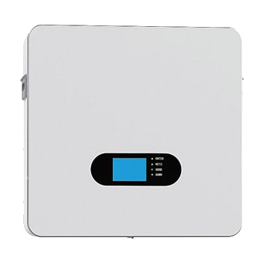48V100AH/200AH LiFePO4

