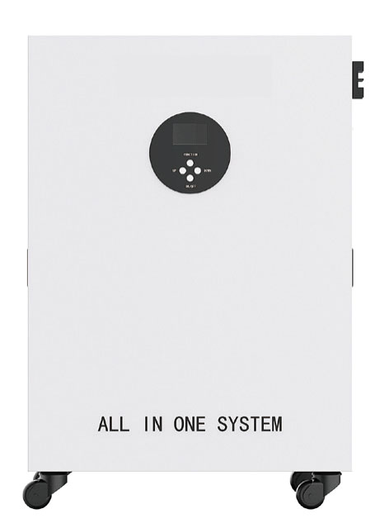
去掉logo

- 1.5KW/2.56KWH
- 3KW/5.12KWH
- 5KW/10.24KWH

